Unit #: 1
Unit Name: Problem Solving Fundamentals
Topic: Basic constructs in C – Identifiers, Keywords, Variables and Data types, Range of values

Course objectives:
The objective(s) of this course is to make students
CObj1: Acquire knowledge on how to solve relevant and logical problems using computing machine
CObj2: Map algorithmic solutions to relevant features of C programming language constructs
CObj3: Gain knowledge about C constructs and it's associated eco-system
CObj4: Appreciate and gain knowledge about the issues with C Standards and it's respective behaviors
CObj5: Get insights about testing and debugging C Programs

Course outcomes:
At the end of the course, the student will be able to
CO1: Understand and apply algorithmic solutions to counting problems using appropriate C Constructs
CO2: Understand, analyse and apply text processing and string manipulation methods using C Arrays, Pointers and functions
CO3: Understand prioritized scheduling and implement the same using C structures
CO4: Understand and apply sorting techniques using advanced C contructs
CO5: Understand and evaluate portable programming techniques using preprocessor directives and conditional compilation of C Programs

Before we start with Problem Solving sessions, let us list few counting problems
- Find the number of times a word is repeated in a given file
- Count the number of different words that can be created using the given characters Count the number of hosts in a network

- Count the number of red pixels in a given image
- What is the ratio of red:green:blue pixels in a given image
- A={a,b,c} and B={y,z}. How many waysare there to create a list of length 3 where the first and second value in the list come from A and the third value in the list comes from B.
- For the sets A={a,b,c} and B={x,y} above, we want to count the number of lists of length 3 where the first two elements come from A, the third element comes from B, and where no two elements in the list are the same.
- How many 7-digit numbers have alternating odd-even digits and no digit repeated.
- …
Problem to be solved at the end of Unit_#1: Count and display the number of characters, words and lines in a user input and in a given file.

Basic constructs in C
C program consists of various tokens and a token can be any identifier -> a keyword, variable, constant, a string literal, or a symbol. For example, the following C statement consists of five tokens.
printf("HelloFriends"); The individual tokens are − printf
(
"HelloFriends"
)
;

Identifiers
An identifier is a name used to identify a variable, function, or any other user-defined item. An identifier starts with a letter A to Z, a to z, or an underscore '_' followed by zero or more letters, underscores and digits (0 to 9). C does not allow few punctuation characters such as #, @ and % within identifiers. As C is a case-sensitive programming language, Manpower and manpower are two different identifiers in C.
Here are some examples of acceptable identifiers _sum stud_name a_123 myname50 temp j count123

Keywords
The keywords are identifiers which have special meaning in C and hence cannot be used as constants or variables. There are 32 keywords in C Language.
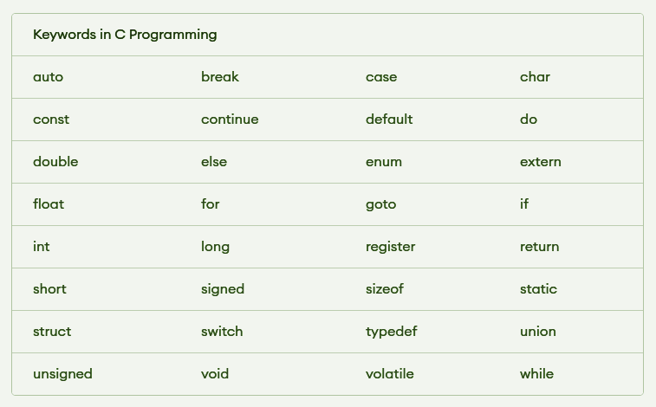
Variables
This is the most important concept in all languages. Variable is a name given to a storage area that our programs can manipulate. It has a name, a value, a location and a type. It also has something called life, scope, qualifiers etc. Variables are used to store information to be referenced and manipulated in a computer program. It provides a way of labeling data with a descriptive name, so our programs can be understood more clearly by the reader and ourselves. It is helpful to think of Variables as containers that hold data or information. Purpose of Variables is to label and store data in memory, which then can be used throughout the program.
Sometimes, the runtime makes variables with no names. These are called temporary variables. We cannot access them by name as we have no name in our vocabulary. A variable has a type. In ‘C’, type should be specified before a variable is ever used. We declare the variable with respect to type before using it. We cannot declare the variable more than once.
Examples: int a; double b;

Rules for naming a Variable aka User defined Identifier:
A Variable name cannot be same as the keyword in c Language. A Variable name should not be same as the standard identifiers in c Language. A Variable name can only have letters (both uppercase and lowercase letters), digits and underscore. The first letter of a Variable should be either a letter or an underscore. There is no rule on how long a variable name aka user defined identifier can be. Variable name may run into problems in some compilers, if the variable name is longer than 31 characters. C is a strongly typed language, which means that the variable type cannot be changed once it is declared.

The type of a variable can never change during the program execution. The type decides what sort of values this variable can take and what operations we can perform. Type is a compile time mechanism. The size of a value of a type is implementation dependent and is fixed for a particular implementation.

Variable is associated with three important terms: Declaration, Definition and Initialization.
- Declaration of a variable is for informing to the compiler the following information: name of the variable, type of value it holds and the initial value if any it takes. Declaration gives details about the properties of a variable.
- Definition of a variable says where the variable gets stored. i.e., memory for the variable is allocated during the definition of the variable. In C language, definition and declaration for a variable takes place at the same time. i.e. there is no difference between declaration and definition.
If we want to only declare variables and not to define it i.e. we do not want to allocate memory, then the following declaration can be used.
extern int a; // We will discuss this in Unit - 5
- Initialization of a variable: We can initialize a variable at the point of declaration. An uninitialized variable within a block has some undefined value. ‘C’ does not initialize any default value.
int c = 100;
int d; // undefined value !! variable can be assigned a value later in the code
int c = 200;
int c; // Declaration again throws an error
d = 300;
Note: Assignment is considered as an expression in ‘C’ .

Data Types
In programming, is a classification that specifies type of value and what type of mathematical, relational or logical operations can be applied to it without causing an error.It deals with the amount of storage to be reserved for the specified variable. Significance of data types are given below:
    - Memory allocation
    - Range of values allowed
    - Operations that are bound to this type
    - Type of data to be stored
Size of a type:
The size required to represent a value of that type. Can be found using an operator called sizeof. The size of a type depends on the implementation. We should never conclude that the size of an int is 4 bytes. Can you answer this question –How many pages a book has? What is the radius of Dosa we get in different eateries?

The sizeof operator is the most common operator in C. It is a compile-time unary operator and is used to compute the size of its operand. It returns the size of a variable/value/type. It can be applied to any data type, float type, pointer type variables When sizeof() is used with the data types, it simply returns the amount of memory allocated to that data type. The output can be different on different machines like a 32-bit system can show different output while a 64-bit system can show different of same data types

The size of a type is decided on an implementation based on efficiency. C standards follow the below Rules.

sizeof(short int)<=sizeof(int)<=sizeof(long int)<=sizeof(long long int)<= sizeof(float)<=sizeof(double)<=sizeof(long double)

Classification of Data types
Data types are categorized into primary and non-primary (secondary) types.
Primary ---> int, float, double, char, void
Secondary---> Derived and User-defined types
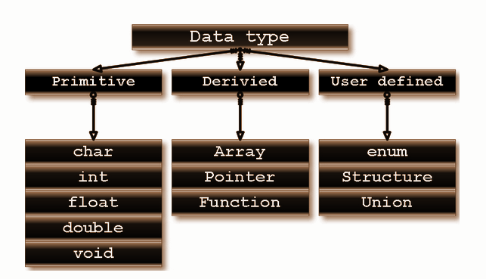

Data types can be extended using qualifiers:
Size and Sign Qualifiers. We will discuss in detail in Unit - 5

Literals
Literals are the constant values assigned to the constant variables. There are four types of literals that exist in c programming:
- Integer literal
- Float literal
- Character literal
- String literal – Will be discussed in Unit – 2

Constant is basically a named memory location in a program that holds a single value throughout the execution of that program
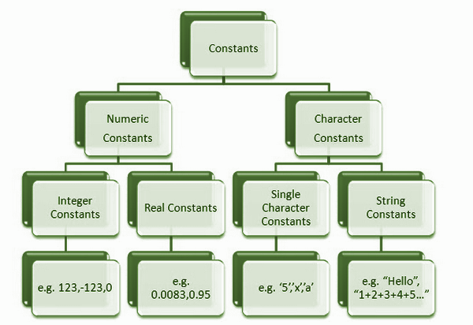

Integer Literal: It is a numeric literal that represents only integer type values. Represents the value neither in fractional nor exponential part. Can be specified in the following three ways
Decimal number (base 10): It is defined by representing the digits between 0 to 9. Example: 1,3,65 etc
Octal number (base 8): It is defined as a number in which 0 is followed by digits such as 0,1,2,3,4,5,6,7. Example: 032, 044, 065, etc
Hexadecimal number (base 16): It is defined as a number in which 0x or 0X is followed by the hexadecimal digits (i.e., digits from 0 to 9, alphabetical characters from (a-f) or (A-F))
Example: 0XFE, oxfe etc..
Float Literal: It is a literal that contains only floating-point values or real numbers. These real numbers contain the number of parts such as integer part, real part, exponential part, and fractional part. The floating-point literal must be specified either in decimal or in exponential form.
Decimal form: Must contain decimal point, real part, or both. If it does not contain either of these, then the compiler will throw an error. The decimal notation can be prefixed either by '+' or '-' symbol that specifies the positive and negative numbers. Example: +9.5, -18.738
Exponential form: The exponential form is useful when we want to represent the number, which is having a big magnitude. It contains two parts, i.e., mantissa and exponent. Example: the number is 3450000000000, and it can be expressed as 3.45e12 in an exponential form

Rules for creating an exponential notation: The mantissa can be specified either in decimal or fractional form An exponent can be written in both uppercase and lowercase, i.e., e and E.
We can use both the signs, i.e., positive and negative, before the mantissa and exponent. Spaces are not allowed.

Character Literal: Contains a single character enclosed within single quotes. If we try to store more than one character in a character literal, then the warning of a multi-character character constant will be generated. A character literal can be represented in the following ways:
It can be represented by specifying a single character within single quotes.
Example: 'x', 'y', etc.
We can specify the escape sequence character within single quotes to represent a character literal.
Example, '\n', '\t', '\b'.
We can also use the ASCII in integer to represent a character literal.
Example: the ascii value of 65 is 'A'.
The octal and hexadecimal notation can be used as an escape sequence to represent a character literal.
Example, '\043', '\0x22'.

Think! What is the maximum and minimum integer value I can store in a variable?
The limits.h header file determines various properties of the various variable types. The macros defined in this header, limits the values of various variable types like char, int and long. These limits specify that a variable cannot store any value beyond these limits The values indicated in the table are implementation-specific and defined with the #define directive, but these values may not be any lower than what is given in the table.
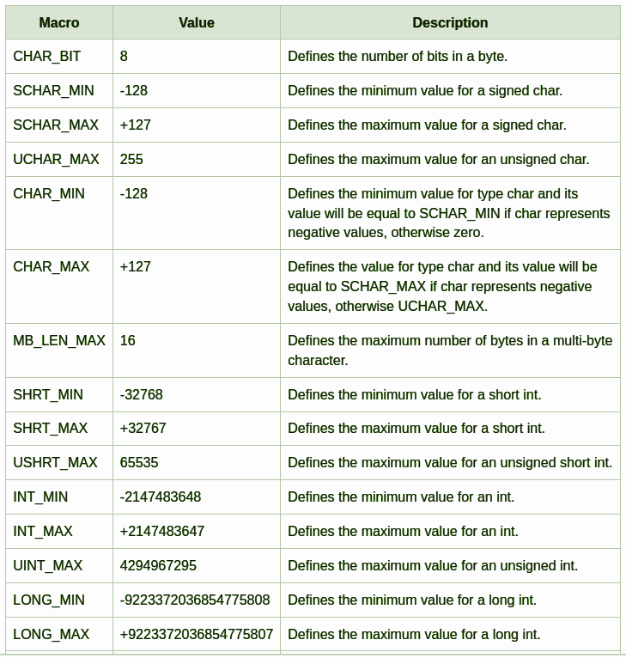

The float.h header file of the c Standard Library contains a set of various platform- dependent constants related to floating point values. These constants are proposed by ANSI C. They allow making more portable programs.

Coding Example_1:
#include<stdio.h>
#include<limits.h>
#include<float.h>
int main()
{
int a = 8;
char p = 'c';
double d = 89.7;
int e = 0113; // octal literal
/*printf("%d\n",e);
printf("%o\n",e);
printf("%X\n",e);
printf("%x\n",e);
*/
//int h = 0xRG; // error
int h = 0xA;
//printf("%d",h);
int i = 0b111;
//printf("%d",i);
//printf("%d %d %d %d\n",sizeof(int),sizeof(short int),sizeof(p),sizeof(long));
//int g = 787878787888888787;
int g = 2147483649;
/*printf("%d\n",INT_MAX);
printf("%d\n",INT_MIN);
printf("%d\n",INT_MIN);
printf("%d\n",INT_MIN);*/
printf("%d\n",CHAR_MAX);
printf("%g\n",DBL_MAX);
printf("%g\n",FLT_MAX);
printf("%d\n",g);
return 0;
}

Question for you to think!
- What is header file?
- What is Library file?
- Is there any difference between the above two?

